Version 1.1

December 7, 2015

Presented by:

DEBAJYOTI DIBYARANJAN NAYAK

Sagar Choudhary

Rahul Bhattad

**noSQL database Design**

MS - Data science (Indian university)



Table of Contents

Project Proposal for 2

“Design of a noSQL database using MONGODB AND 2

Cassandra for Big Data” 2

Team: 2

Email: 2

Description: 2

Section 1: Data Modeling using Cassandra 2

Section 2: Data Modeling using MongoDB 2

Environment: 2

Deliverable: 3

Project Work for 4

“Design of a noSQL database using MONGODB 4

AND Cassandra for Big Data” 4

Overview 4

Section 1: Database design using Cassandra 4

Project Environment: 4

Installation of Cassandra. 4

Entity-Relationship diagram 6

Database Schema 6

Import data: 19

Screens shots 20

Delivered: 21

Section 2: Database design using MongoDB 22

Project Environment: 22

Installation of Mongo DB. 22

Sample Raw data 23

Data Cleanup (Reformat) 23

Query and Update 24

Screenshots 26

Delivered: 29

# Project Proposal for

# “Design of a noSQL database using MONGODB AND

# Cassandra for Big Data”

# Team:

* Rahul Bhattad,
* Sagar Choudhary,
* Debajyoti Nayak

# Email:

1. Rahul Bhattad ([bhattadr2007@gmail.com](mailto:bhattadr2007@gmail.com) )
2. Sagar Choudhary([sagar.choudhary@gmail.com](mailto:sagar.choudhary@gmail.com) )
3. Debajyoti Nayak ([debajyoti.nayak@gmail.com](mailto:debajyoti.nayak@gmail.com) )

# Description:

This project is divided into 2 sections:

# Section 1: Data Modeling using Cassandra

The objective of Section 1 is to design a data model leveraging Cassandra for Ratting data of Videos/actors, users etc. , additionally ingest and query a large dataset using Cassandra. We will also provide some scripts to cleanup and import the data.

# Section 2: Data Modeling using MongoDB

The objective of Section 2 is to design a data model leveraging MongoDB for location data, additionally ingest and query a large dataset using MongoDB. We will also provide some scripts to cleanup and import the data.

# Environment:

* Oracle Enterprise Linux.
* MongoDB
* Google Map
* Shell Scripts
* JAVA
* Cassandra

# Deliverable:

* Instructions
* MongoDB/Cassandra Schema design
* Sample raw data and cleaned Dataset.
* Shell Scripts
* MongoDB/Cassandra scripts
* MongoDB/Cassandra files

# Project Work for

# “Design of a noSQL database using MONGODB

# AND Cassandra for Big Data”

# Overview

This project is divided into 2 sections.

Section 1 describes the Database design using Cassandra and Section 2 describes the Database design using MongoDB.

What is Cassandra?

Apache **Cassandra** is an open source distributed **database** management system designed to handle large amounts of data across many commodity servers, providing high availability with no single point of failure. It is a noSQL database with SQL interface for the schema design and playing with data.

What is MongoDB?

**MongoDB** is an open source, document-oriented database designed with both scalability and developer agility in mind. Instead of storing your data in tables and rows as you would with a relational database, in **MongoDB** you store JSON-like documents with dynamic schemas.

# Section 1: Database design using Cassandra

# Project Environment:

1. Red Hat Enterprise Linux Server release 5.9 (Tikanga)
2. Cassandra
3. OpenSSL

# Installation of Cassandra.

1. Install JAVA
   1. tar -zxf jdk-8u65-linux-x64.tar.gz
2. setup environment
   1. JAVA_HOME=/usr/local/java/jdk1.8.0_65
   2. PATH=$PATH:$HOME/bin:$JAVA_HOME/bin
   3. JRE_HOME=/usr/local/java/jdk1.8.0_65
   4. PATH=$PATH:$HOME/bin:$JRE_HOME/bin
   5. export JAVA_HOME
   6. export JRE_HOME
   7. export PATH
3. Install Cassandra
   1. tar -zxf apache-cassandra-2.2.3-bin.tar.gz
   2. mv apache-cassandra-2.2.3 ~/cassandra
4. Set environment Variable
5. sudo mkdir /var/lib/cassandra
6. sudo mkdir /var/log/cassandra
7. sudo chown -R $USER:$GROUP /var/lib/cassandra
8. sudo chown -R $USER:$GROUP /var/log/cassandra
9. export CASSANDRA_HOME=~/cassandra
10. export PATH=$PATH:$CASSANDRA_HOME/bin
11. start database Cassandra
12. sudo sh ~/cassandra/bin/cassandra
13. Start cqlsh
14. sudo sh ~/cassandra/bin/cqlsh

# Entity-Relationship diagram

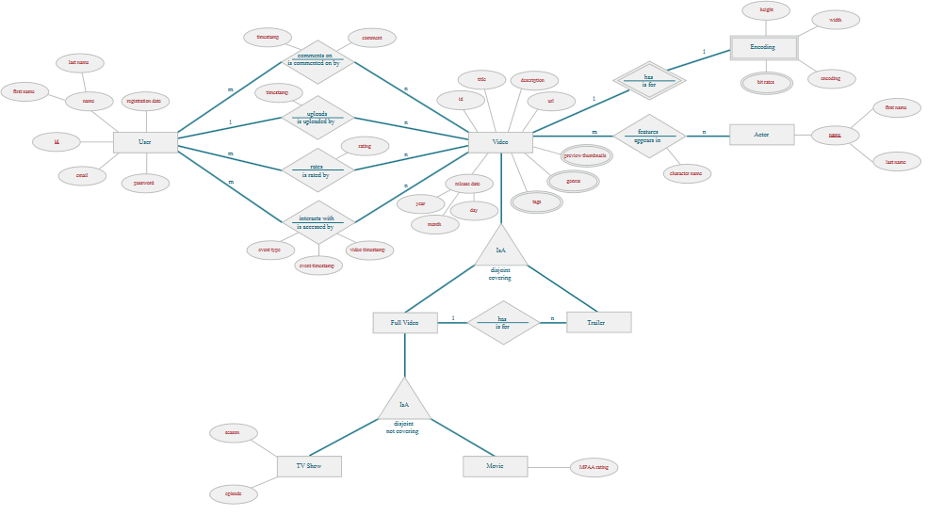

# Database Schema

Here we have created following tables: Table Schemas are separated by color coding

* 1. encoding_type
  2. trailers_by_video
  3. users
  4. videos
  5. users_by_email
  6. latest_videos
  7. comments_by_user
  8. actors_by_video
  9. video_interactions_by_user_video
  10. videos_by_user
  11. ratings_by_video
  12. comments_by_video

cqlsh:killr_video> describe keyspace killr_video;

CREATE KEYSPACE killr_video WITH replication = {'class': 'SimpleStrategy', 'replication_factor': '1'} AND durable_writes = true;

CREATE TYPE killr_video.encoding_type (

encoding text,

height int,

width int,

bit_rates frozen<set<text>>

);

CREATE TABLE killr_video.trailers_by_video (

video_id timeuuid,

title text,

trailer_id timeuuid,

preview_thumbnails map<int, blob>,

tags set<text>,

type text,

PRIMARY KEY (video_id, title, trailer_id)

) WITH CLUSTERING ORDER BY (title ASC, trailer_id ASC)

AND bloom_filter_fp_chance = 0.01

AND caching = '{"keys":"ALL", "rows_per_partition":"NONE"}'

AND comment = ''

AND compaction = {'class': 'org.apache.cassandra.db.compaction.SizeTieredCompactionStrategy'}

AND compression = {'sstable_compression': 'org.apache.cassandra.io.compress.LZ4Compressor'}

AND dclocal_read_repair_chance = 0.1

AND default_time_to_live = 0

AND gc_grace_seconds = 864000

AND max_index_interval = 2048

AND memtable_flush_period_in_ms = 0

AND min_index_interval = 128

AND read_repair_chance = 0.0

AND speculative_retry = '99.0PERCENTILE';

CREATE TABLE killr_video.users (

user_id uuid PRIMARY KEY,

email text,

first_name text,

last_name text,

registration_date timestamp

) WITH bloom_filter_fp_chance = 0.01

AND caching = '{"keys":"ALL", "rows_per_partition":"NONE"}'

AND comment = ''

AND compaction = {'class': 'org.apache.cassandra.db.compaction.SizeTieredCompactionStrategy'}

AND compression = {'sstable_compression': 'org.apache.cassandra.io.compress.LZ4Compressor'}

AND dclocal_read_repair_chance = 0.1

AND default_time_to_live = 0

AND gc_grace_seconds = 864000

AND max_index_interval = 2048

AND memtable_flush_period_in_ms = 0

AND min_index_interval = 128

AND read_repair_chance = 0.0

AND speculative_retry = '99.0PERCENTILE';

CREATE TABLE killr_video.videos (

video_id timeuuid PRIMARY KEY,

avg_rating float,

description text,

encoding frozen<encoding_type>,

genres set<text>,

mpaa_rating text,

preview_thumbnails map<int, blob>,

release_date timestamp,

tags set<text>,

title text,

type text,

url text,

user_id uuid

) WITH bloom_filter_fp_chance = 0.01

AND caching = '{"keys":"ALL", "rows_per_partition":"NONE"}'

AND comment = ''

AND compaction = {'class': 'org.apache.cassandra.db.compaction.SizeTieredCompactionStrategy'}

AND compression = {'sstable_compression': 'org.apache.cassandra.io.compress.LZ4Compressor'}

AND dclocal_read_repair_chance = 0.1

AND default_time_to_live = 0

AND gc_grace_seconds = 864000

AND max_index_interval = 2048

AND memtable_flush_period_in_ms = 0

AND min_index_interval = 128

AND read_repair_chance = 0.0

AND speculative_retry = '99.0PERCENTILE';

CREATE TABLE killr_video.users_by_email (

email text PRIMARY KEY,

password text,

user_id uuid

) WITH bloom_filter_fp_chance = 0.01

AND caching = '{"keys":"ALL", "rows_per_partition":"NONE"}'

AND comment = ''

AND compaction = {'class': 'org.apache.cassandra.db.compaction.SizeTieredCompactionStrategy'}

AND compression = {'sstable_compression': 'org.apache.cassandra.io.compress.LZ4Compressor'}

AND dclocal_read_repair_chance = 0.1

AND default_time_to_live = 0

AND gc_grace_seconds = 864000

AND max_index_interval = 2048

AND memtable_flush_period_in_ms = 0

AND min_index_interval = 128

AND read_repair_chance = 0.0

AND speculative_retry = '99.0PERCENTILE';

CREATE TABLE killr_video.latest_videos (

video_bucket int,

video_id timeuuid,

preview_thumbnails map<int, blob>,

tags set<text>,

title text,

type text,

PRIMARY KEY (video_bucket, video_id)

) WITH CLUSTERING ORDER BY (video_id DESC)

AND bloom_filter_fp_chance = 0.01

AND caching = '{"keys":"ALL", "rows_per_partition":"NONE"}'

AND comment = ''

AND compaction = {'class': 'org.apache.cassandra.db.compaction.SizeTieredCompactionStrategy'}

AND compression = {'sstable_compression': 'org.apache.cassandra.io.compress.LZ4Compressor'}

AND dclocal_read_repair_chance = 0.1

AND default_time_to_live = 0

AND gc_grace_seconds = 864000

AND max_index_interval = 2048

AND memtable_flush_period_in_ms = 0

AND min_index_interval = 128

AND read_repair_chance = 0.0

AND speculative_retry = '99.0PERCENTILE';

CREATE TABLE killr_video.comments_by_user (

user_id uuid,

posted_timestamp timestamp,

video_id timeuuid,

comment text,

preview_thumbnails map<int, blob>,

tags set<text>,

title text,

type text,

PRIMARY KEY (user_id, posted_timestamp, video_id)

) WITH CLUSTERING ORDER BY (posted_timestamp DESC, video_id ASC)

AND bloom_filter_fp_chance = 0.01

AND caching = '{"keys":"ALL", "rows_per_partition":"NONE"}'

AND comment = ''

AND compaction = {'class': 'org.apache.cassandra.db.compaction.SizeTieredCompactionStrategy'}

AND compression = {'sstable_compression': 'org.apache.cassandra.io.compress.LZ4Compressor'}

AND dclocal_read_repair_chance = 0.1

AND default_time_to_live = 0

AND gc_grace_seconds = 864000

AND max_index_interval = 2048

AND memtable_flush_period_in_ms = 0

AND min_index_interval = 128

AND read_repair_chance = 0.0

AND speculative_retry = '99.0PERCENTILE';

CREATE TABLE killr_video.actors_by_video (

video_id timeuuid,

actor_name text,

character_name text,

PRIMARY KEY (video_id, actor_name, character_name)

) WITH CLUSTERING ORDER BY (actor_name ASC, character_name ASC)

AND bloom_filter_fp_chance = 0.01

AND caching = '{"keys":"ALL", "rows_per_partition":"NONE"}'

AND comment = ''

AND compaction = {'class': 'org.apache.cassandra.db.compaction.SizeTieredCompactionStrategy'}

AND compression = {'sstable_compression': 'org.apache.cassandra.io.compress.LZ4Compressor'}

AND dclocal_read_repair_chance = 0.1

AND default_time_to_live = 0

AND gc_grace_seconds = 864000

AND max_index_interval = 2048

AND memtable_flush_period_in_ms = 0

AND min_index_interval = 128

AND read_repair_chance = 0.0

AND speculative_retry = '99.0PERCENTILE';

CREATE TABLE killr_video.video_interactions_by_user_video (

user_id uuid,

video_id timeuuid,

event_timestamp timestamp,

event_type text,

video_timestamp timestamp,

PRIMARY KEY ((user_id, video_id), event_timestamp)

) WITH CLUSTERING ORDER BY (event_timestamp DESC)

AND bloom_filter_fp_chance = 0.01

AND caching = '{"keys":"ALL", "rows_per_partition":"NONE"}'

AND comment = ''

AND compaction = {'class': 'org.apache.cassandra.db.compaction.SizeTieredCompactionStrategy'}

AND compression = {'sstable_compression': 'org.apache.cassandra.io.compress.LZ4Compressor'}

AND dclocal_read_repair_chance = 0.1

AND default_time_to_live = 0

AND gc_grace_seconds = 864000

AND max_index_interval = 2048

AND memtable_flush_period_in_ms = 0

AND min_index_interval = 128

AND read_repair_chance = 0.0

AND speculative_retry = '99.0PERCENTILE';

CREATE TABLE killr_video.videos_by_user (

user_id uuid,

video_id timeuuid,

preview_thumbnails map<int, blob>,

tags set<text>,

title text,

type text,

PRIMARY KEY (user_id, video_id)

) WITH CLUSTERING ORDER BY (video_id DESC)

AND bloom_filter_fp_chance = 0.01

AND caching = '{"keys":"ALL", "rows_per_partition":"NONE"}'

AND comment = ''

AND compaction = {'class': 'org.apache.cassandra.db.compaction.SizeTieredCompactionStrategy'}

AND compression = {'sstable_compression': 'org.apache.cassandra.io.compress.LZ4Compressor'}

AND dclocal_read_repair_chance = 0.1

AND default_time_to_live = 0

AND gc_grace_seconds = 864000

AND max_index_interval = 2048

AND memtable_flush_period_in_ms = 0

AND min_index_interval = 128

AND read_repair_chance = 0.0

AND speculative_retry = '99.0PERCENTILE';

CREATE TABLE killr_video.ratings_by_video (

video_id timeuuid PRIMARY KEY,

num_ratings counter,

sum_ratings counter

) WITH bloom_filter_fp_chance = 0.01

AND caching = '{"keys":"ALL", "rows_per_partition":"NONE"}'

AND comment = ''

AND compaction = {'class': 'org.apache.cassandra.db.compaction.SizeTieredCompactionStrategy'}

AND compression = {'sstable_compression': 'org.apache.cassandra.io.compress.LZ4Compressor'}

AND dclocal_read_repair_chance = 0.1

AND default_time_to_live = 0

AND gc_grace_seconds = 864000

AND max_index_interval = 2048

AND memtable_flush_period_in_ms = 0

AND min_index_interval = 128

AND read_repair_chance = 0.0

AND speculative_retry = '99.0PERCENTILE';

CREATE TABLE killr_video.comments_by_video (

video_id timeuuid,

posted_timestamp timestamp,

user_id uuid,

comment text,

preview_thumbnails map<int, blob> static,

tags set<text> static,

title text static,

type text static,

PRIMARY KEY (video_id, posted_timestamp, user_id)

) WITH CLUSTERING ORDER BY (posted_timestamp DESC, user_id ASC)

AND bloom_filter_fp_chance = 0.01

AND caching = '{"keys":"ALL", "rows_per_partition":"NONE"}'

AND comment = ''

AND compaction = {'class': 'org.apache.cassandra.db.compaction.SizeTieredCompactionStrategy'}

AND compression = {'sstable_compression': 'org.apache.cassandra.io.compress.LZ4Compressor'}

AND dclocal_read_repair_chance = 0.1

AND default_time_to_live = 0

AND gc_grace_seconds = 864000

AND max_index_interval = 2048

AND memtable_flush_period_in_ms = 0

AND min_index_interval = 128

AND read_repair_chance = 0.0

AND speculative_retry = '99.0PERCENTILE';

# Import data:

COPY videos FROM 'videos.csv' WITH HEADER=true;

COPY latest_videos FROM 'latest_videos.csv' WITH HEADER=true;

COPY trailers_by_video FROM 'trailers_by_video.csv' WITH HEADER=true;

COPY actors_by_video FROM 'actors_by_video.csv' WITH HEADER=true;

# Screens shots

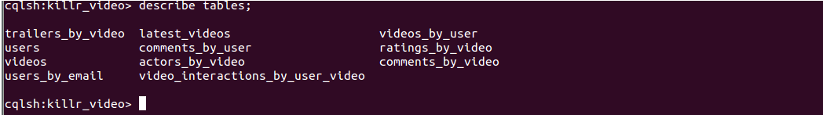

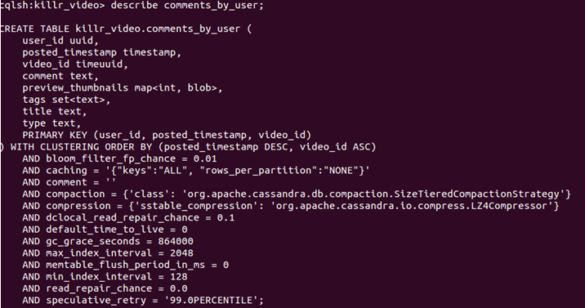

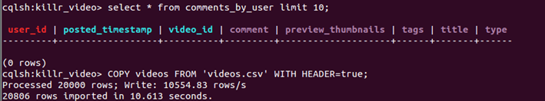

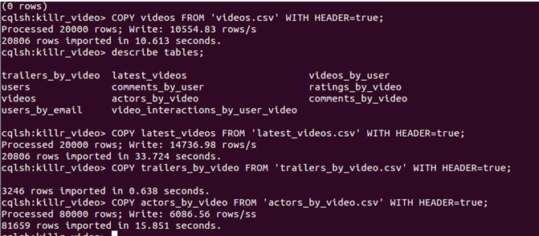

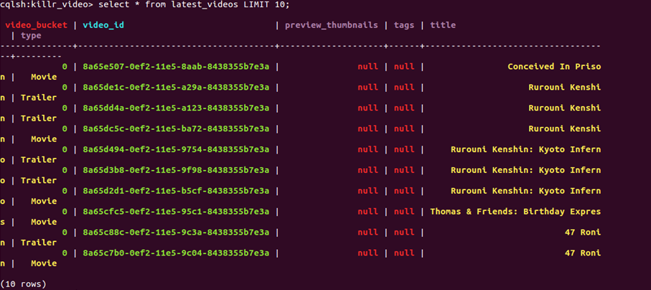

# Delivered:

File Name : Cassandra.zip

Input file : Inputdata.zip

Output/DB Dump: killr_video.tar.gz

Database Schema: schema_describe

# Section 2: Database design using MongoDB

# Project Environment:

1. Red Hat Enterprise Linux Server release 5.9 (Tikanga)
2. mongodb-linux-x86_64-rhel62-3.0.7
3. OpenSSL

# Installation of Mongo DB.

1. Install OpenSSL
   1. $ ./config
   2. $ make
   3. $ make test
   4. $ make install
2. Intall MongoDB
   1. tar –xvf mongodb-linux-x86_64-rhel62-3.0.7

# Sample Raw data

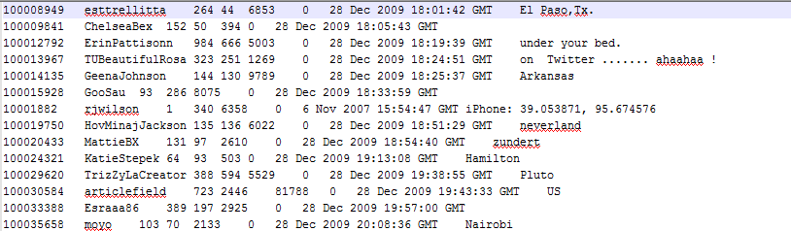

# Data Cleanup (Reformat)

The raw txt file of user profiles is encoded in ISO-8859-1 format. This is a format that the MongoDB NoSQL store does not accept, a common problem. So you will need to convert the txt file into the UTF-8 format that MongoDB accepts. You need to do this before you can store the Twitter user profiles into the MongoDB database. Reformat the user profile twitter dataset from ISO-8859-1 to UTF-8 format by running the following reformatting script that is in your bin directory. Name the output file

reformat.sh <input file> <output file>



Double click on the file you created to bring the file up in the “gedit” editor. Add the following line as the first line to the newly reformatted Twitter data file (it becomes the “headerline”,something MongoDB understands). Be sure that you use tabs to split the fields.

user_id user_name friend_count follower_count status_count favorite_count

account_age user_location

**Create database, table and import data.**

The tab-separated values (tsv) file can be imported directly into MongoDB, however, proper header lines (fields) must be defined so that MongoDB can give structure to the data when converting it to its internal format. Next you will import the data into MongoDB. To do so, run the following script which exists in your bin directory. Note that <import file type> is tsv. Choose your own <db name> and <collection name>.

./bin/import_mangodb.sh <db name> <collection name> <import file type>

<import file>



The above script contains mongoDB script “mongoimport --db $1 --collection $2 --type $3 --headerline --file $4“

Here is the sample JSON data from the exported database

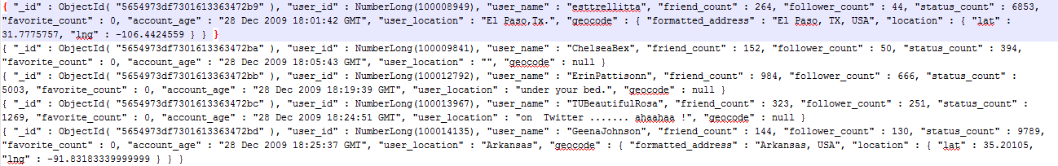

# Query and Update

**Query and Update the User Profile Collection: QueryAndUpdate.sh**

The Twitter user profile permits a Twitter user to input arbitrary text as their location meaning user locations may be fabricated. Through the QueryAndUpdate.sh tool you will access the Google geocoding API to validate user locations and extract valid Latitude/Longitude of the user locations. If you are interested in what the Google geocoding API does, take a look here <https://developers.google.com/maps/documentation/geocoding>

Simple but workable software for doing the geocoding is QueryAndUpdate.sh. It’s a script, but you should peek at the Java code that the script invokes to see how it works. The Java code is at src/google/GeoCodingClient.java (see tree structure above). QueryAndUpdate.sh allows you to specify an authentication option in the configuration file that you can find in the config directory (see tree structure above). While Google provides three authentication options, you will use the anonymous user option:

Anonymous user: limited to making 2500 geocoding queries per day. To use this option, leave all authentication configuration parameters blank. This means you will need to run your tool 4 times over 4 days to finish geocoding all 10,000 user profiles. This workaround is simpler than the other authentication options.

QueryAndUpdate.sh <configuration file> <db name> <collection name> <query criteria file> <log file>





A sample of the geocode information that is added by the Google geocoding service is given below

{

"geocode" : {

"formatted_address" : "Noel N5, Kitimat-Stikine D, BC V0J, Canada",

"location" : { "lat" : 57.4755555, "lng" : -132.3597222 } }}

**Other Mongodb queries:**

1. Access MongoDB

$ mongo

> use twittercollection

switched to db twittercollection

1. Find a user

>db. twittercollection.find({user_id:100008949})

Result

{ "_id" : ObjectId("5415fc01d77bc408f1397df5"), "user_id" : NumberLong(100008949),"user_name" : "esttrellitta", "friend_count" : 264, "follower_count" : 44, "status_count" : 6853, "favorite_count" : 0, "account_age" : "28 Dec 2009 18:01:42 GMT", "user_location" : "El Paso,Tx." }

1. Update user

db.twittercollection.update({user_id:100008949},{$set: {geolocation :{formatted_address: "El Paso, TX, USA", location:{lat: 31.7775757, lng:-106.6359219}}}})

1. Verify update

db.twittercollection.find({user_id:100008949})

Result

{ "_id" : ObjectId("5415fc01d77bc408f1397df5"), "user_id" : NumberLong(100008949), "user_name" : "esttrellitta", "friend_count" : 264, "follower_count" : 44, "status_count" : 6853, "favorite_count" : 0, "account_age" : "28 Dec 2009 18:01:42 GMT", "user_location" : "El Paso,Tx.", "geolocation" : { "formatted_address" : "El Paso, TX, USA", "location" : { "lat" :31.7775757, "lng" : -106.6359219 } } }

1. Find user who has no Geocode

{"geocode": {"$exists": false}}

1. Find the user whose geocode is null

db.twittercollection.find({"geocode": {"$eq": Null}}).count()

1. Find the user whose geocode is null

db.twittercollection.find({"geocode": {"$ne": Null}}).count()

User detail who has geocode is null

db.twittercollection.find({"geocode": {"$eq": Null}}).Pretty()

Additional reference for the query criteria is here:

<http://docs.MongoDB.org/manual/core/crud-introduction/#query>

# Screenshots

Code and configuration file structure

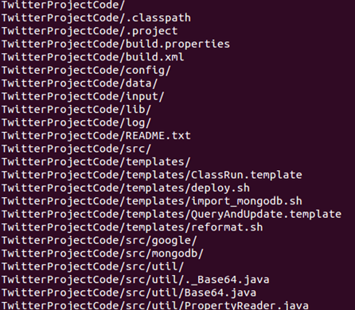

Data clean-up using script.

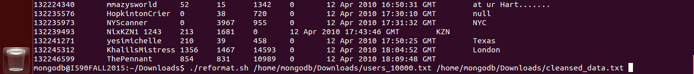

Importing of data into Mongo db



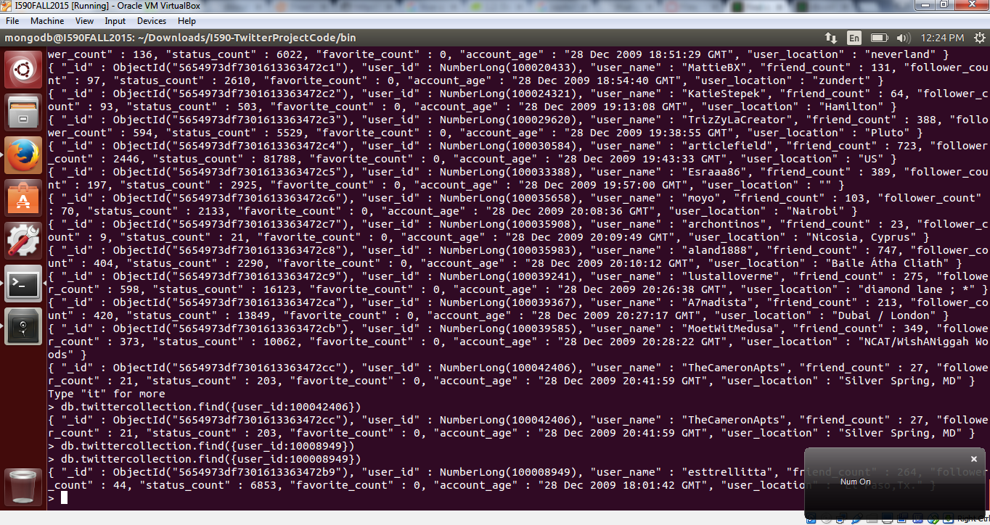

Users with no location

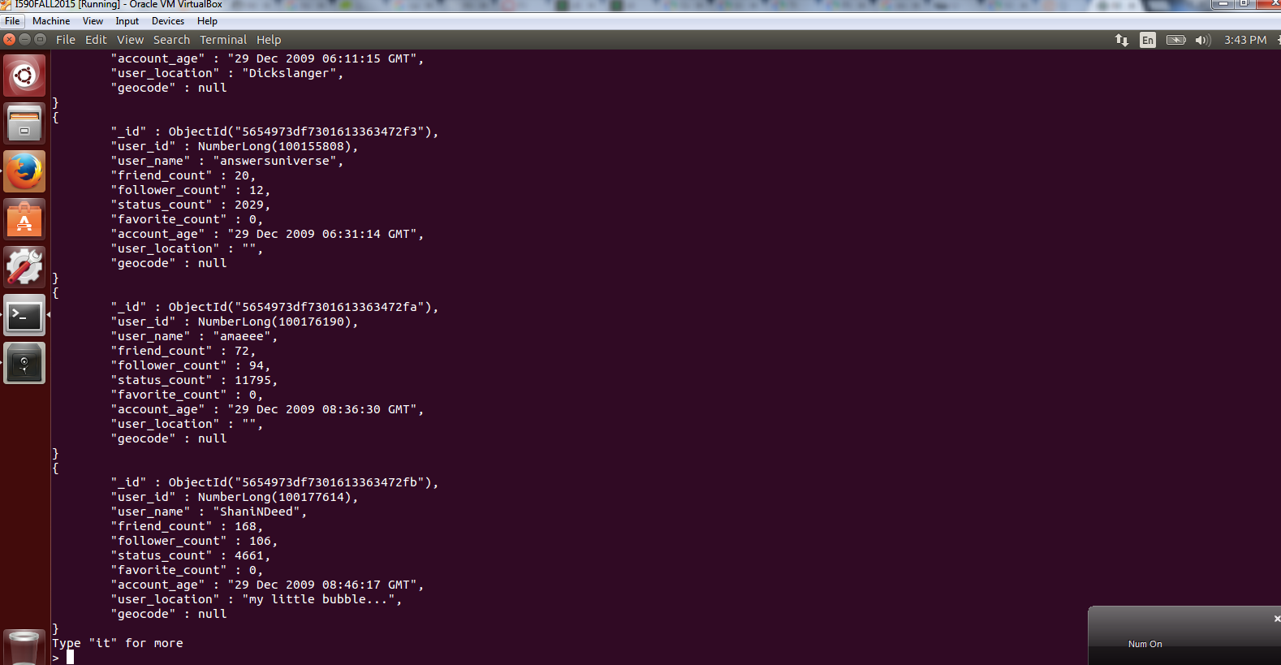

Users with location and no location count

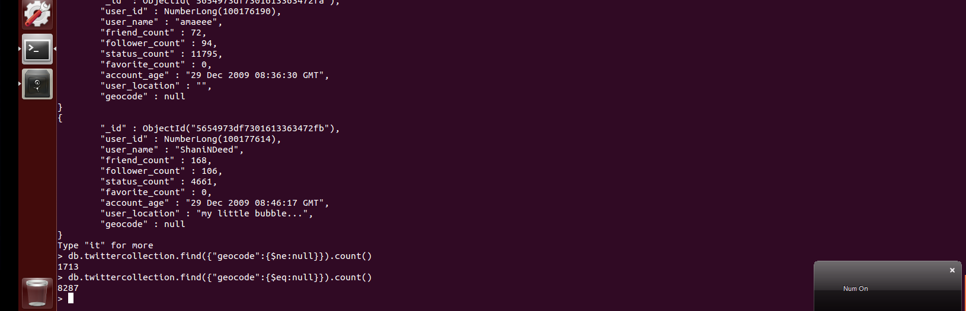

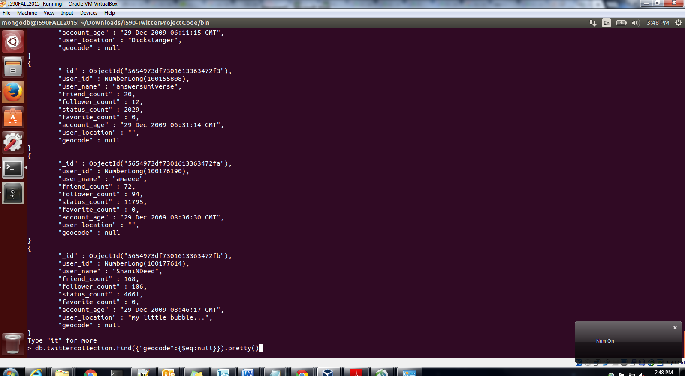

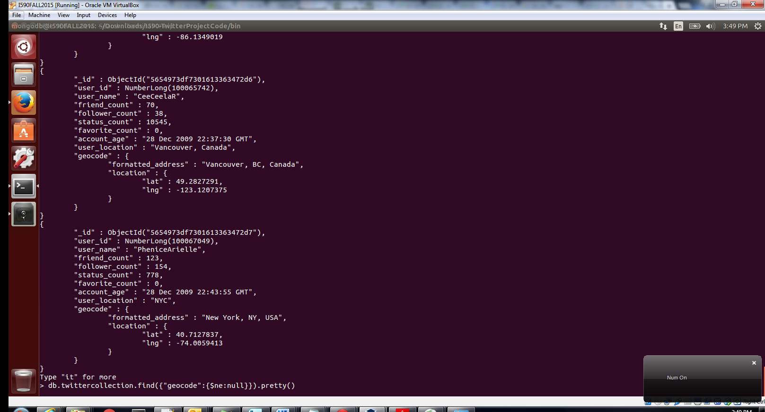

# Delivered:

File Name: mongodb.zip

1. Shell script
2. Mogodb Scripts
3. Input Data
4. Output data/DB dump
5. Java code, library files, config files